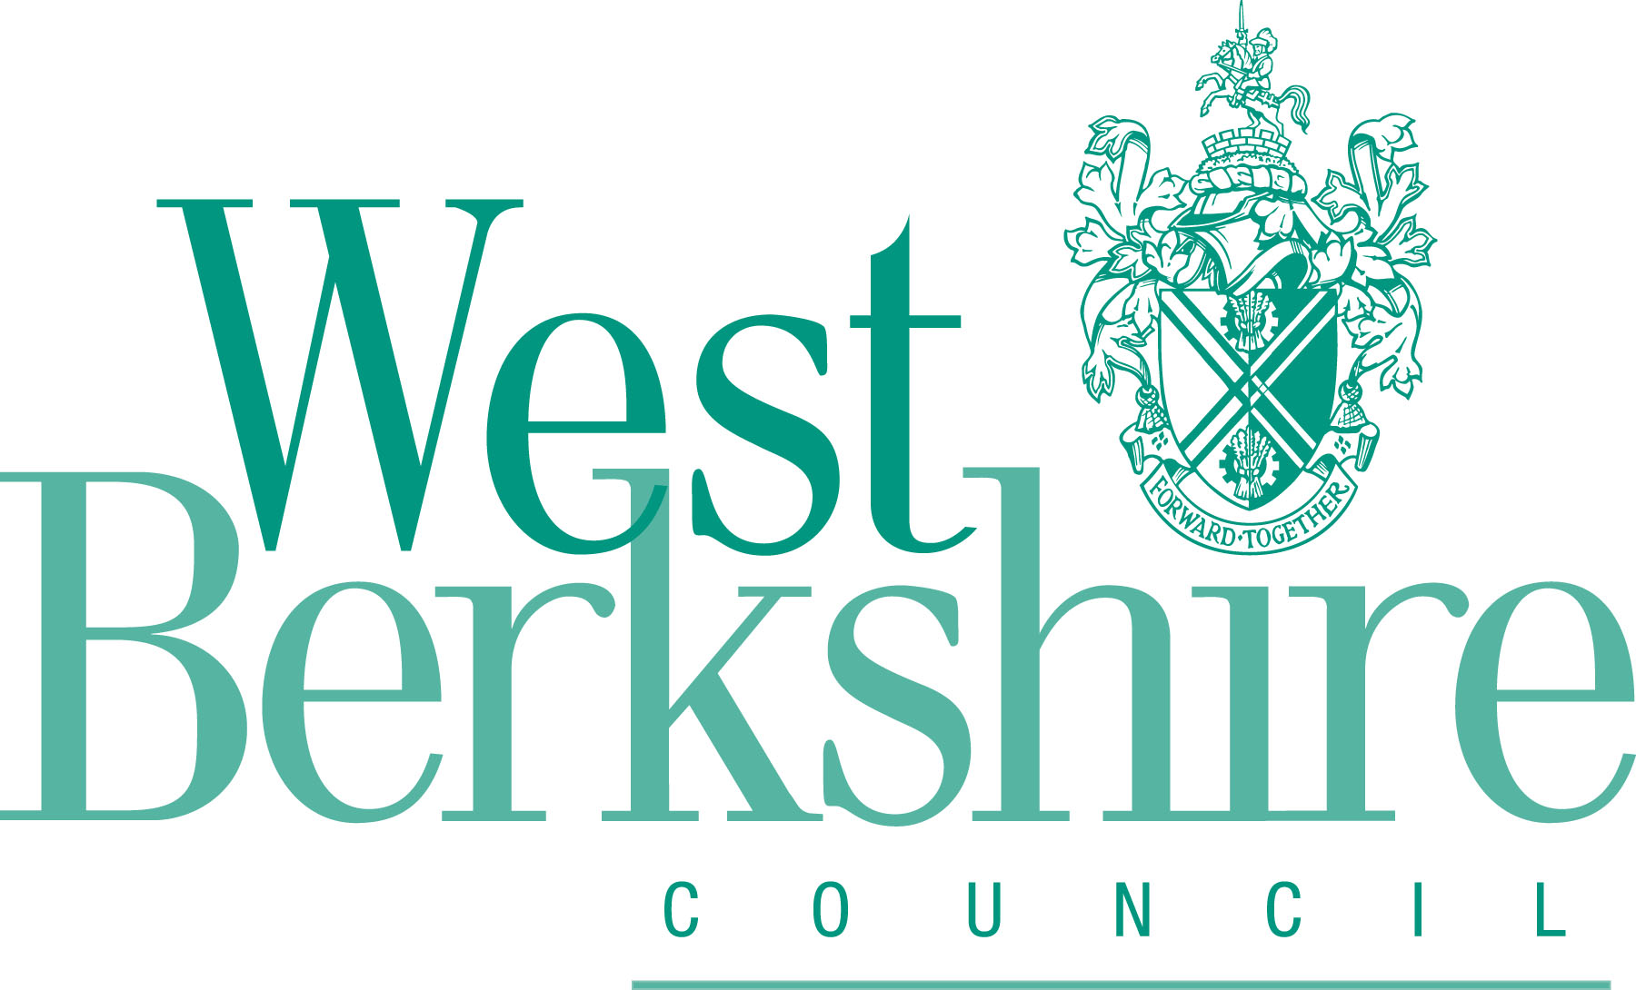 | Consultation on the Lambourn Neighbourhood Development Plan (Regulation 16 Consultation)  Representation Form  Ref:  (For official use only)

Please complete online or return this form to: | By email: planningpolicy@westberks.gov.uk
Please complete online or return this form to: | By post: Planning Policy Team, Development and Housing, West Berkshire Council, Council Offices, Market Street, Newbury, RG14 5LD
Return by: | 11:59pm on Tuesday 30 June 2026

This form has three parts:

- Part A - Your details: need only be completed once
- Part B - Your representation(s): please fill in a separate sheet for each representation you wish to make
- Part C - Notification of progress of the Lambourn Neighbourhood Development Plan

PART A: Your Details

Please note the following:

- We cannot register your representation without your details.
- Representations cannot be kept confidential and will be available for public scrutiny, however, your contact details will not be published.
- All personal data will be handled in line with the Council’s Privacy Policy on the Development Plan. You can view the Council’s privacy notices at http://info.westberks.gov.uk/privacynotices

 | Your details | Agent’s details (if applicable)
Title:
First Name:*
Last Name:*
Job title
(where relevant):
Organisation
(where relevant):
Address*
Please include postcode:
Email address:*
Telephone number:
*Mandatory field
Part B – Your Representation

Please use a separate sheet for each representation

Your name or organisation (and client if you are an agent):

Please indicate which part of the consultation documents that this representation relates to:
Policy:
Section/paragraph:
Appendix:

Comments

Please use the space below and overleaf to provide your comments on the content of the submitted Lambourn NDP and its supporting documents.

Comments can also be made on the implications for the submission Lambourn NDP arising from recent legislative changes*

* Since the Lambourn NDP was submitted to West Berkshire Council in February 2026, legislative changes have been introduced through the Levelling Up and Regeneration Act 2023 (Commencement No.11 and Saving and Transitional Provisions). These changes amend some of the legal compliance requirements and Basic Conditions against which the Lambourn NDP will be examined. The Basic Conditions are a set of statutory tests which all NDPs must comply with.

These changes came into effect 25 March 2026 and introduce the following new legal compliance requirements:

- Climate change:
So far as the qualifying body (Lambourn Parish Council) considers appropriate, and having regard to the subject matter of the plan, the plan must be designed to secure that the development and use of land in the neighbourhood area contribute to the mitigation of, and adaptation to, climate change; and

- Local Nature Recovery Strategies:
So far as the qualifying body considers appropriate and having regard to the subject matter of the plan, the plan must be designed to take account of any local nature recovery strategy under section 104 of the Environment Act 2021 that relates to all or part of the neighbourhood plan area.

Local nature recovery strategies (LNRS) are spatial documents that are designed to map the most valuable nature habitats within the areas they cover, as well as having opportunities for recovering and enhancing nature.

The Berkshire LNRS, which covers the whole of Berkshire, was published on 7 October 2025 and can be viewed at: https://rbwmtogether.rbwm.gov.uk/berkshire-local-nature-recovery-strategy.

The legislation also introduces the following new Basic Condition:

- the making of the neighbourhood development plan would not result in the development plan for the area of the authority proposing that less housing is provided by means of development taking place in that area than if the neighbourhood development plan were not to be made.

This new Basic Condition replaces the former requirement that a neighbourhood plan be in general conformity with the strategic policies contained in the development plan for the area.

A further Basic Condition relating to the new environmental assessment framework has been commenced. However, until a framework for the implementation of Environmental Assessment Reports is in place, compliance with this Basic Condition cannot yet be assessed.
PART C – Notification of progress of the Lambourn NDP

Do you wish to be notified of any of the following?

Please tick all that apply

Publication of the Examiners report / Decision to progress to referendum
Decision to adopt the Lambourn NDP

Signature |  | Date

Your completed representations must be received by the Council by 11:59pm on
Tuesday 30 June 2026.

