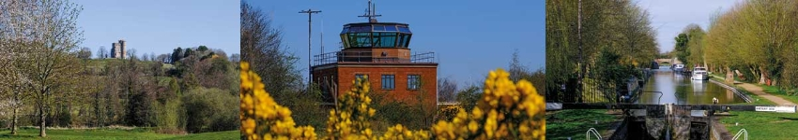

Council Report for October 2025

Written by your local Conservative team to keep you up to date.

Councillor Clive Hooker, Downlands Ward

West Berkshire Council

Council
Council met on 16 October to discuss:
- Hungerford Neighbourhood Development Plan (C4742)
- Youth Justice Plan 2025/26 (C4666)
Papers and a recording of the meeting can be found here.
The next meeting is on 4 and 27 November.

Executive
There was no meeting of the Executive this month.
The next meeting is on 6 Nov.

Local Government Reorganisation

Councils propose new local government structure for Oxfordshire and West Berkshire
Five councils have joined forces on proposal which responds to Government plans for a major reform of Local Government.
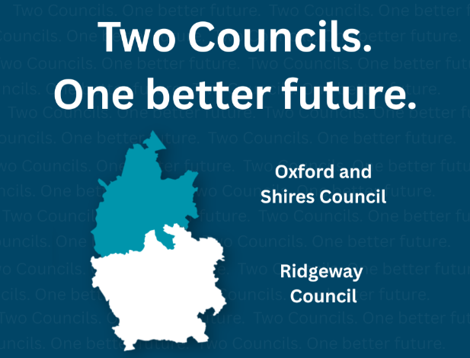
The plan would create two new unitary authorities - Oxford and Shires Council, and Ridgeway Council - designed to improve services, save money, and better support local communities. West Berkshire would be part of the new Ridgeway Council, which also covers South Oxfordshire and Vale of White Horse.
Financial modelling suggests this proposal could save nearly £60 million a year, making it the most cost-effective option among the three options being put forward. The new councils aim to balance efficiency with local accountability, ensuring high-quality services and strong democratic representation.
The draft proposal is subject to approval by all five councils involved. Residents can read the full proposal or a summary online at twocouncils.org. Once approved it will be submitted to Government, who are expected to hold a consultation in 2026 and possible implementation by 2028.

Environment

Soil Conditioner Give Away
In October WBC hosted the seventh Soil Conditioner Giveaway. Over the two days, 515 cars visited the site and took away 96 tonnes of nutrient-rich soil conditioner, made from locally recycled food and garden waste. A huge thank you to everyone who came along. It is fantastic that there are so many green-fingered residents with autumn gardening plans.

Bee Bus Shelters
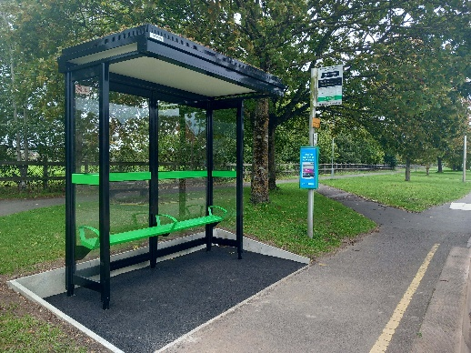
Bus Passengers across West Berkshire are beginning to benefit from new bus shelters being installed, helping to improve the Public Transport experience. WBC have provided funding to town and parish councils who are responsible for maintaining shelters.

Many of the shelters have green roofs helping to contribute towards efforts to tackle the climate and ecological emergency. It follows feedback from bus surveys, where residents said the condition of bus stops influences how they travel.

These improvements are made possible by funding from HM Government, given to the Council after submission of the Bus Service Improvement Plan (BSIP).

Safe Battery Disposal
Batteries contain hazardous materials that can harm the environment and pose fire risks, so they should never be disposed of in household bins.

Residents can put used batteries in a see-through bag and place them sealed on top of the black wheelie bin ready for collection on black bin collection day. Waste vehicles have a special compartment designed for these batteries ensuring they're safely recycled. Residents can also take non-household batteries (car batteries etc) to recycling centres for disposal.

Health and Social Care

Children’s Services Rated Good
WBC are celebrating the result of the latest Ofsted inspection, which rated Children’s Services as ‘Good’ across all key areas. This includes support for children in care, care leavers, and those needing protection.
The inspection praised the dedication of staff and leaders who have continued to put children and families at the heart of their work since the last inspection in 2022, when the service was rated ‘Good’ across all areas. They noted strong leadership, improved workforce stability and enhanced support systems.
This success reflects the whole council’s ambition that every child in West Berkshire will be given the care and support they need to thrive.

Countryside

Streatley Footpath 21 officially open
After 20 years of anticipation, WBC are delighted to share that Streatley Footpath 21 is now open for everyone to enjoy!
Originally established in 2004 as part of planning permission for The Swan Hotel, the footpath remained unusable for many years due to challenging terrain, including drainage ditches, dense vegetation, and persistently wet ground.
Over the past five years, Countryside and Public Rights of Way Teams have led a series of improvements guided by ecological recommendations. These included safety tree work supported by bat surveys, vegetation clearance, water level studies, and the installation of two bridges.
A big thank you to all those involved in making this happen including: Mid and West Berkshire Local Access Forum, Mend the Gap, The Swan Hotel, the Berkshire Ornithological Club, the Mobility Issues Group for Goring and Streatley (MIGGS), and neighbouring landowners.

Community

Memorandum of Understanding
Last month, WBC signed a new Memorandum of Understanding (MOU) with key voluntary and charitable organisations to support local people.
The MOU was developed in partnership with Volunteer Centre West Berkshire, which will coordinate volunteer recruitment and support; Connecting Communities in Berkshire, focused on community engagement and outreach; Greenham Trust, providing funding and grant support; Berkshire Community Foundation, offering philanthropic and project funding; and Council teams from Place and Children’s Services, managing service delivery and strategy alignment.
WBC already have strong relationships across the sector, especially through Health and Wellbeing Board groups and VCS-led forums. This new agreement gives us a clearer framework to strengthen those ties, making it easier to share ideas, plan jointly, and deliver effective services.

Counterfeit Toys
As the festive season nears, many families shop for toys, but not all are safe. Counterfeit toys, often sold online or by unofficial retailers, may look appealing but lack UK safety standards.
These fakes are often made with poor materials, can break easily, contain toxic chemicals, or pose choking hazards. Unlike genuine products, they rarely undergo testing for age-appropriateness, flammability, or durability, and often lack CE or UKCA marks.
Buy only from reputable stores and check labels for manufacturer details, safety warnings, and certification. If a deal seems too good to be true, it probably is.
Protect children by making informed choices. For concerns about goods or suppliers, email Trading Standards at tsadvice@westberks.gov.uk

Stay Safe this Bonfire Night
As bonfire night approaches, Royal Berkshire Fire and Rescue Service is urging residents to stay safe when celebrating.
Follow these tips to help stay safe during Bonfire Night:
- Only buy fireworks with a UKCA or CE mark from reputable retailers
- Don’t set off fireworks when under the influence of alcohol
- Never go near a firework that has been lit – even if it has gone off, it could still explode
- Never give sparklers to children under the age of five
- Be considerate to animals when letting off fireworks – let neighbours know in advance so they can care for pets
- Ensure firework displays are over by midnight (the cut off time by law)
- Once the firework debris has cooled down, tidy it up and soak in water overnight before putting it in a rubbish bag in the bin

Current Consultations
- Springfield Primary School - School Streets Scheme - Closes 2nd December 2025
- Health Visiting Service feedback survey (October 2025) - Closes 23rd November 2025
- Extension of pedestrianisation hours for Newbury Town Centre from 10am-5pm to 10am-11pm - Closes 19th November 2025
- Proposed Traffic Regulation Order: Thatcham 20mph speed limit - Closes 5th November 2025

Councillor Clive Hooker
Downlands Ward
clive.hooker@westberks.gov.uk
07798 920981

